*Concentration on core business*

**Möhlenhoff sells off its Trench Heater segment**

**Salzgitter, April 2016 – Möhlenhoff, the specialist for heating, ventilation and air conditioning solutions based in Salzgitter, has divested itself of its trench heater segment. The company has sold the business unit to its longstanding Russian partner in order to focus more strongly on its core segments of drive technology and room-by-room temperature control.**

The company, a pioneer in the development of trench heaters, reacted with this decision to falling sales in recent years. The decline, which in 2015 amounted to more than 30 percent from the previous year, was caused in particular by the political situation in Russia and Ukraine. As Möhlenhoff did not foresee an end to the crisis even in the long term, it decided to divest itself of its trench heater product segment.

“Needless to say, it was hard to give up this well-established line of business, especially since our company owes its growth to the development of trench heaters. But with this sale we intend to focus more strongly on our core segments of drive technology and room-by-room temperature control for OEM customers,” explains CEO Frank Geburek. “In addition, we are sure that our longstanding Russian business partner will successfully continue our trench heater business and serve our customers well.”

Möhlenhoff says that it will retain as many employees as possible from its trench heater business unit. The company will use the resources that have been freed to strengthen and expand its core business in the OEM domain.

*1,580 characters (incl. spaces)*

**Captions:**

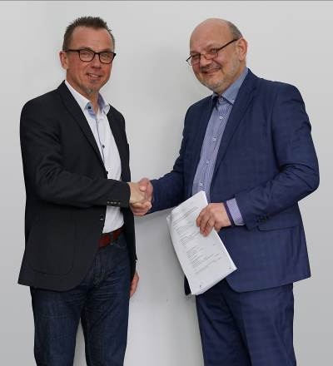

**Image 1:** Frank Geburek (l.), CEO of Möhlenhoff, and Victor A. Ryabtsev, CEO of the Russian business partner, are signing the contract.

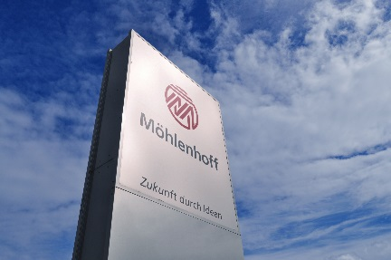

**Image 2:** In order to focus more strongly on its core segments of actuator technology and room-by-room temperature control, Möhlenhoff sold its trench heater segment.

**Images: Möhlenhoff GmbH Salzgitter**

**Möhlenhoff GmbH**

Based in Salzgitter, Germany, Möhlenhoff GmbH is a supplier of products and systems for the heating, ventilation and air conditioning industry. The company specializes in the development and manufacture of solutions for electronic room-by-room temperature control and smart home technology. Möhlenhoff is the global market leader in the field of thermal actuators. Over a period of more than 30 years, the company has established itself as a reliable, expert partner for OEM customers in these sectors. In 2015, the company's 192 employees achieved sales of 39.4 million euros.